Directions:
You will be working independently and you are responsible for creating a five panel comic book. Your comic book must have a story - a title, main characters, a conflict and an ending.

You must use text and pictures (simple stick figures
will do) AND you must include 5 examples of
onomatopoeia - one in each box (these should be big and
bold).

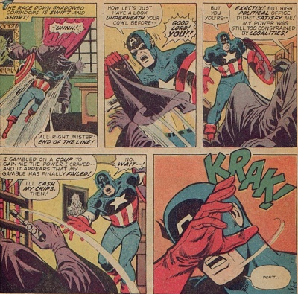

USE THE TEMPLATE PROVIDED IN CLASS.
MAKE IT BOLD, COLORFUL AND INTERESTING!!!!
HAVE FUN!!!!!!

